**Tutorial No. 03**

**Title**: HTML5 Form handling.

# Batch: B2 Roll No.: 16010421119 Tutorial No.: 3

**Aim**: To design forms using HTML 5 Input Elements and Attributes

# Resources needed: Web browser , HTML Editor/Notepad ++, Bracket, and Sublime Text

Theory: HTML Forms are the way of accepting input/data from the website user. There are some basic HTML form input elements such as text, checkboxes, radio buttons, select option and some basic attributes such as name, id, checked and so on. HTML 5 has introduced many more input elements such as email, password etc. as well as many useful attributes which makes the form more user friendly.

**Activity: Students are required to design form using HTML 5 input elements and attributes**

# Result: Code and Output

<!DOCTYPE html>

<html>

<head>

<meta charset="UTF-8" />

<title>Styled HTML Form</title>

<style>

form {

max-width: 500px;

margin: 0 auto;

background-color: #f8f8f8;

padding: 20px;

border-radius: 10px;

font-family: Arial, sans-serif;

}

label {

display: block;

margin-bottom: 10px;

font-weight: bold;

}

input[type="text"],

input[type="email"],

textarea {

padding: 10px;

border: none;

border-radius: 5px;

width: 100%;

margin-bottom: 20px;

box-sizing: border-box;

font-size: 16px;

}

textarea {

height: 150px;

}

input[type="checkbox"] {

margin-right: 10px;

}

input[type="submit"] {

background-color: #4caf50;

color: #fff;

border: none;

padding: 10px 20px;

border-radius: 5px;

cursor: pointer;

font-size: 16px;

}

input[type="submit"]:hover {

background-color: #3e8e41;

}

</style>

</head>

<body>

<form>

<label for="name">Name:</label>

<input type="text" id="name" name="name" placeholder="Enter your name" />

<label for="email">Email:</label>

<input type="email" id="email" name="email" placeholder="Enter your email" />

<label for="message">Message:</label>

<textarea id="message" name="message" placeholder="Enter your message"></textarea>

<label for="subscribe">Subscribe:</label>

<input type="checkbox" id="subscribe" name="subscribe" />Subscribe to

newsletter

<input type="submit" value="Submit" />

</form>

</body>

</html>

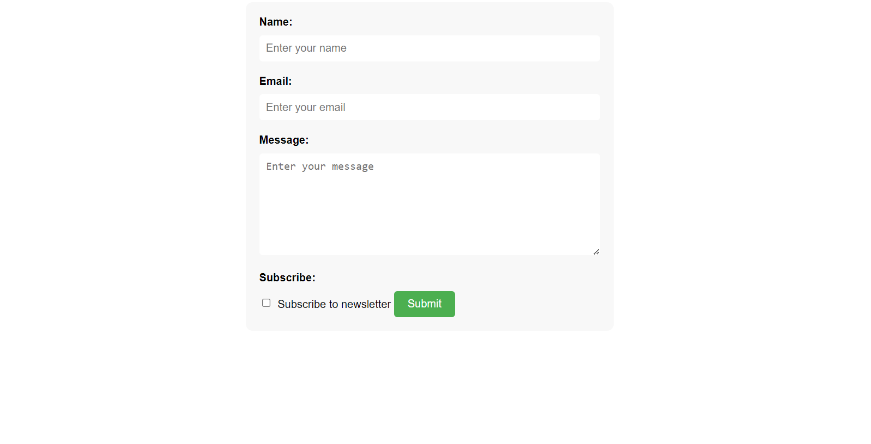

**Outcomes:**

**CO2: Create Web pages using HTML 5 and CSS**

# Conclusion: (Conclusion to be based on the outcomes achieved)

**We can conclude that we have learnt about HTML5 Forms**

# Grade: AA / AB / BB / BC / CC / CD /DD

Signature of faculty in-charge with date

**References:**

**Books/ Journals/ Websites:**

* "HTML5: Black Book", Dreamtech Publication.
* "Web Technologies: Black Book", Dreamtech Publication.
* [http://www.w3schools.com](http://www.w3schools.com/)